1. **INTRODUCTION:**

Agricultural crop production is a fundamental component of agriculture and plays a crucial role in providing food security and sustaining economics worldwide. It is the main source of livelihood, it provides a source for the people to earn. Most of the population in the rural area is dependent on agriculture as their main source of income.

The initial stages and processes involved in cultivating and growing crops for various purposes, such as food production, fiber production, or bio-fuel production. It encompasses a range of activities, including land preparation, planting irrigation, fertilization, pest control, and harvesting. The major agricultural products can be widely grouped into categories of food grains, fibers and raw materials. India has witnessed a number of revolutions that is, the green revolution, yellow revolution, blue revolution, agriculture.

* 1. **OVERVIEW:**

The agricultural crop production analysis project from 1997 to 2021 aims to analyze and understand the trends, patterns, and factors that have influenced crop yields over this period. By examining historical data, researchers and farmers can gain valuable insights into the most efficient and sustainable farming techniques and technologies.

The project will focus on identifying strategies to maximize crop productivity and improve overall yields. Furthermore, the analysis of crop production data will provide farmers with valuable information to make informed decisions about which crops to grow, when to plant and harvest, and how to manage pests and diseases.

Overall, the agricultural crop production analysis project from 1997 to 2021 aims to achieve improved crop yields, enhanced resource management, risk mitigation, informed decision-making, policy development, and the promotion of sustainable agriculture. These achievements will contribute to increased productivity, reduced environmental impacts, and improved livelihoods for farmers worldwide.

**1.2PURPOSE:**

The use of agricultural crop production analysis from 1997 to 2021 has been instrumental in understanding and improving crop production practices. Through the analysis of data collected over these years, researchers and farmers have been able to identify trends, patterns, and factors that affect crop yields and productivity.

Another important use of agricultural crop production analysis is in predicting and managing risks. By analyzing historical data, researchers can identify potential risks such as weather events, pest outbreaks, or market fluctuations that may impact crop production. This information allows farmers to take proactive measures to mitigate these risks, such as implementing crop insurance, diversifying their crops, or adjusting planting schedules.

1. **PROBLEM DEFINITION & DESIGN THINKING:**

The problem definition of agricultural crop production involves the challenges and objectives related to producing crops efficiently and sustainably. This includes factors such as increasing yield and crop quality, improving resource management, optimizing use of fertilizers and pesticides, mitigating environmental impact, and ensuring food security.

The aim is to maximize productivity while minimizing costs and negative effects on the environment, thereby ensuring a reliable supply of high-quality crops to meet the needs of a growing population. Various strategies and technologies can be employed to address these challenges, such as precision agriculture, conservation practices, crop rotation, genetic engineering, and innovative irrigation methods.

* 1. **EMPATHY MAP:**

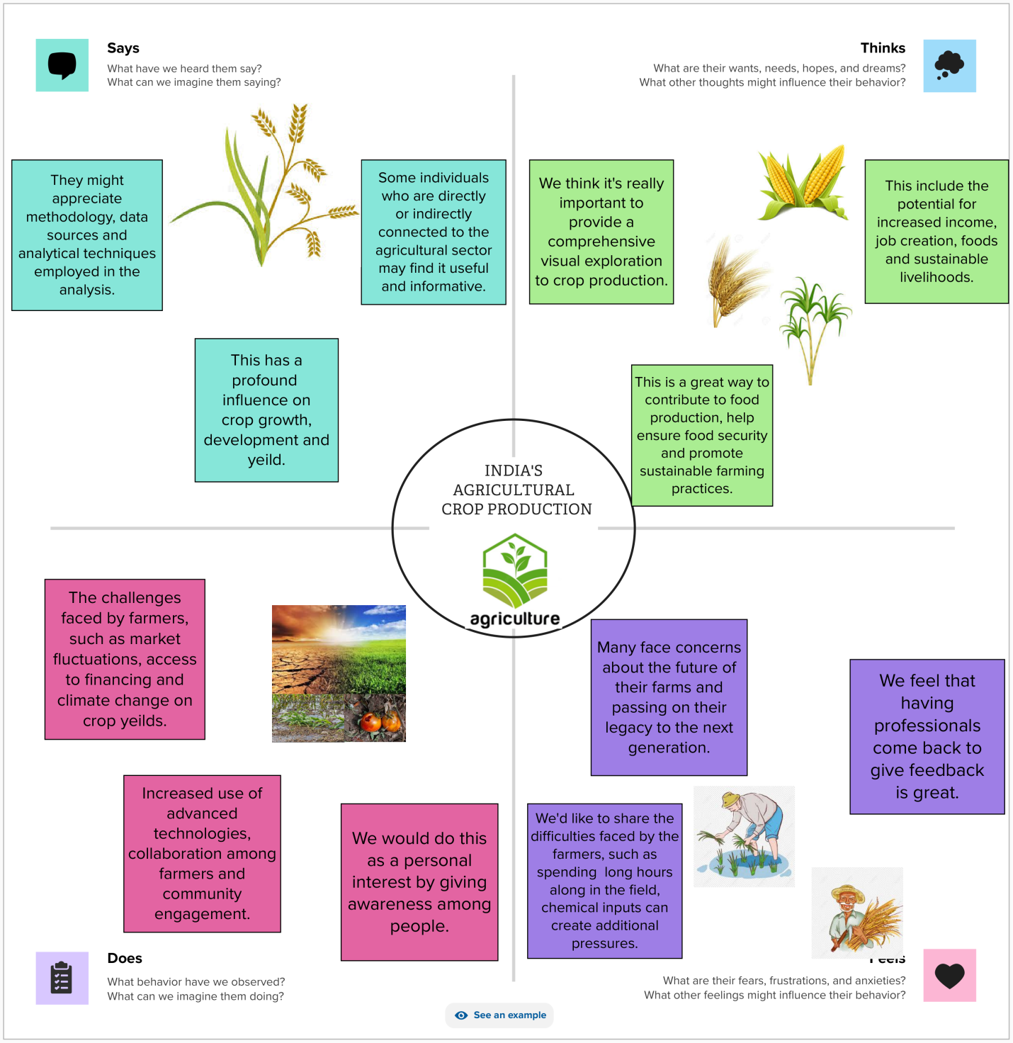

* 1. **IDEATION & BRAINSTORMING MAP:**

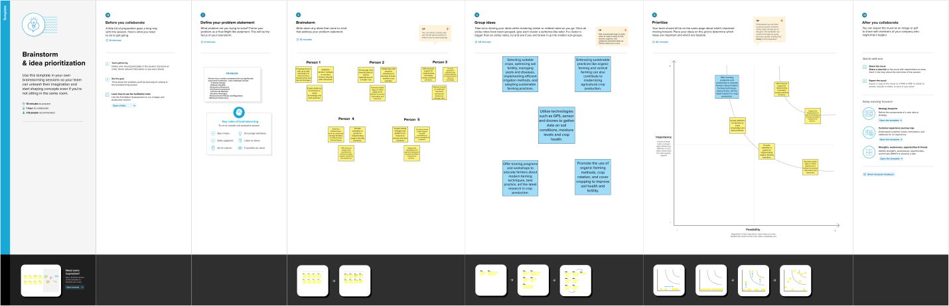

1. **RESULT:**

**3.1DASHBOARD:**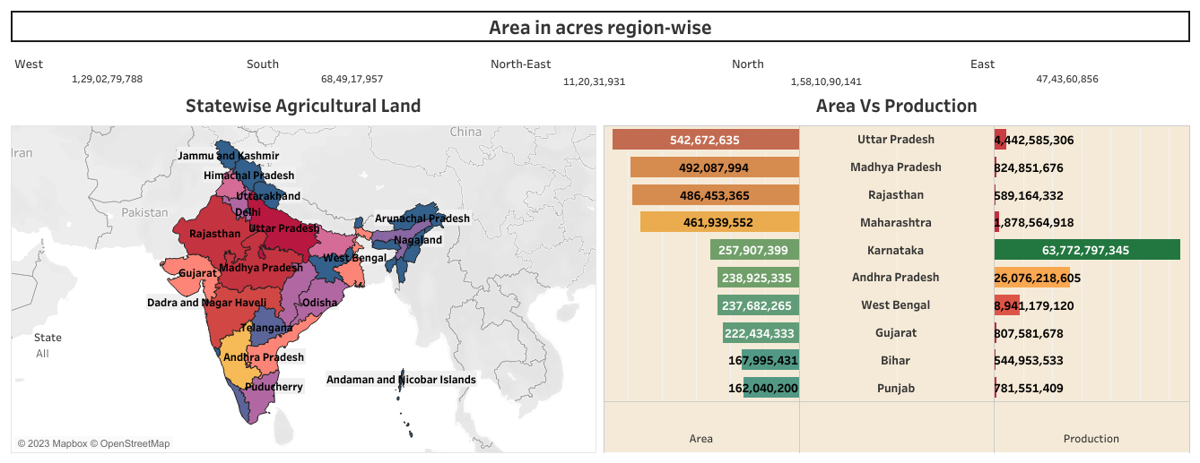

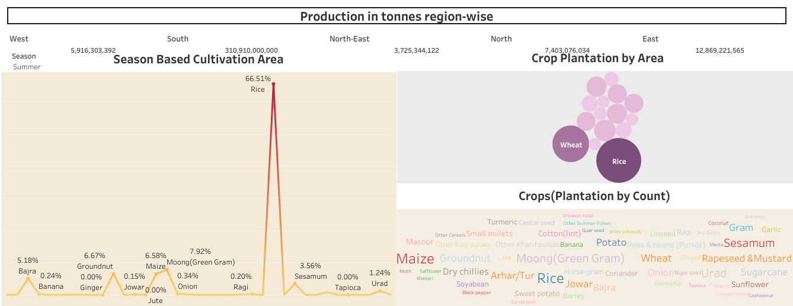

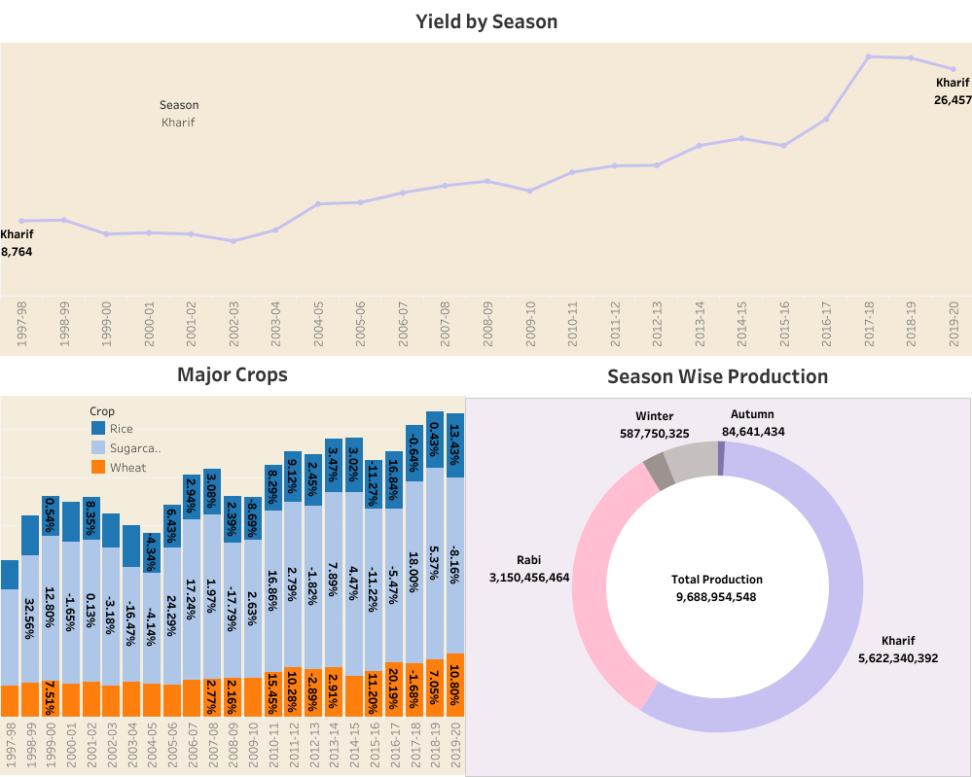

**3.2STORY:**

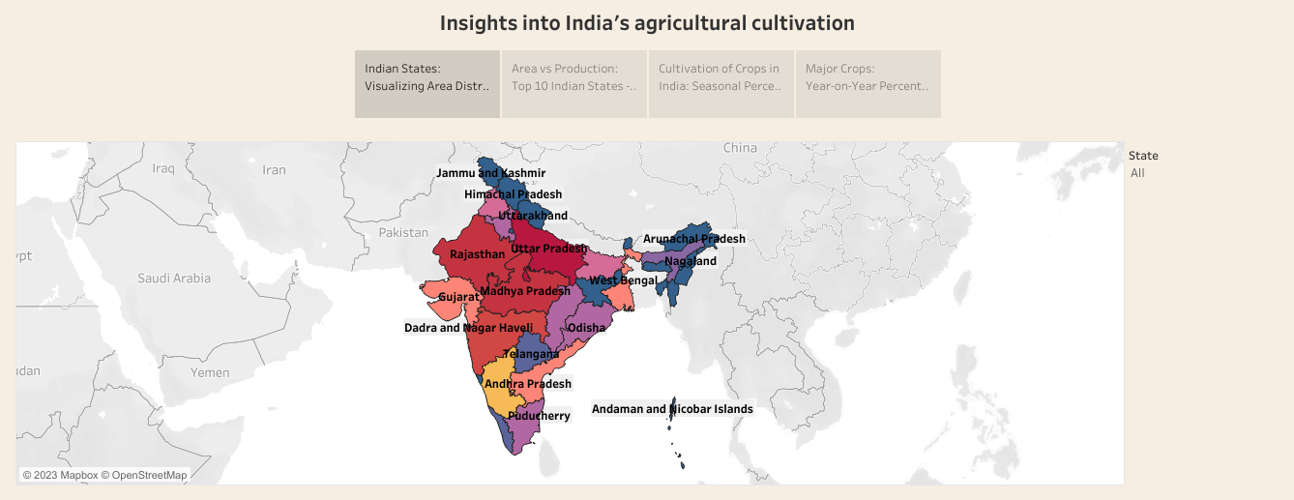

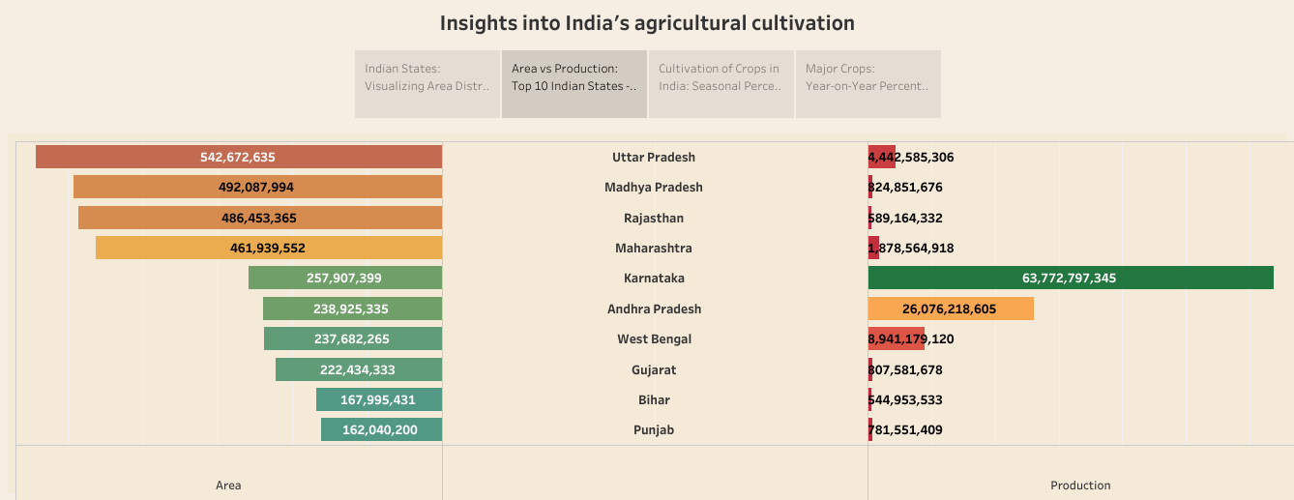

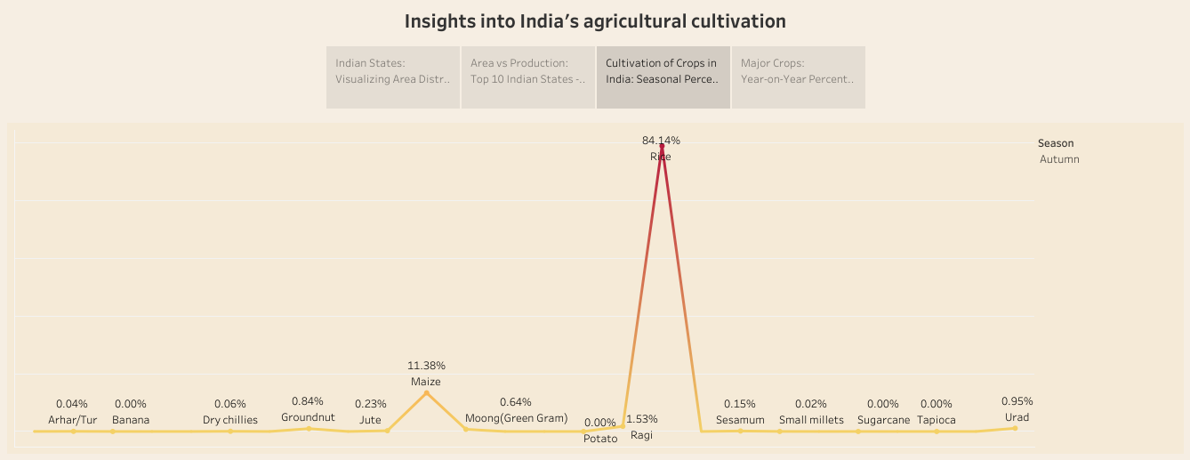

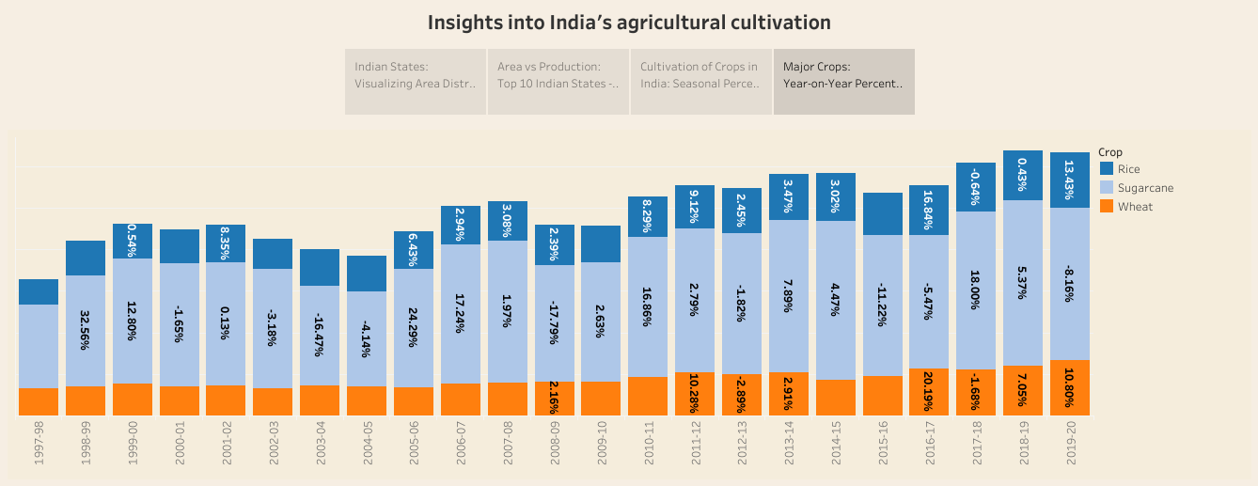

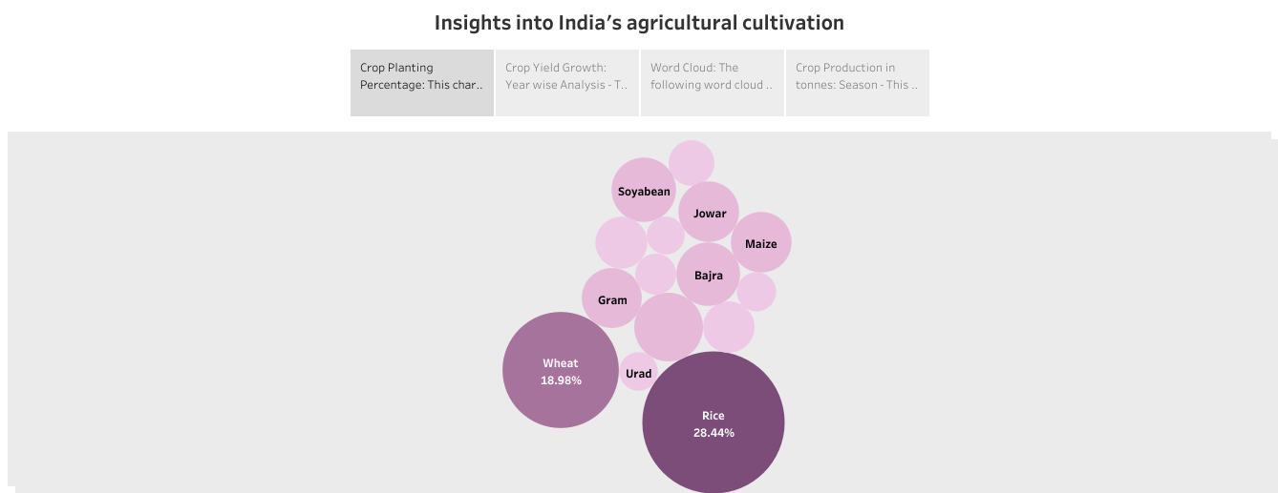

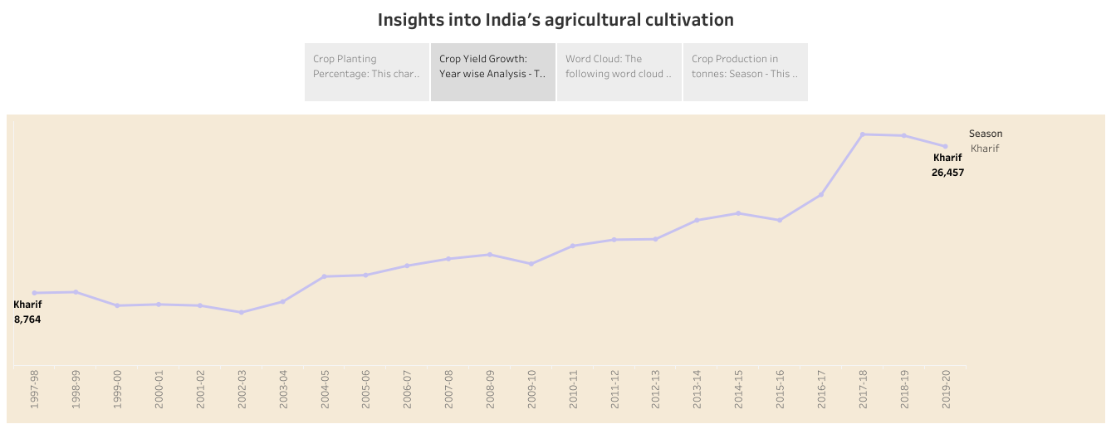

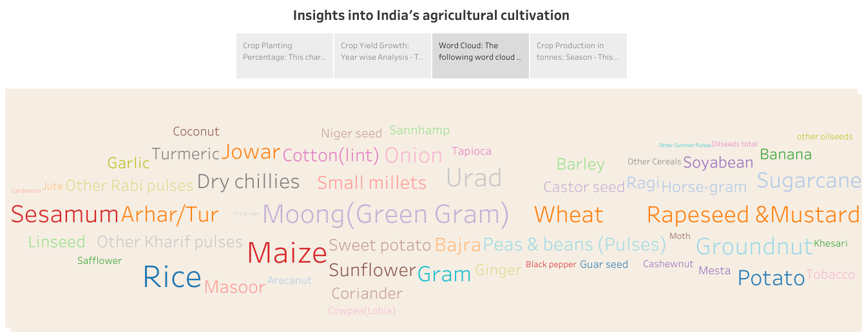

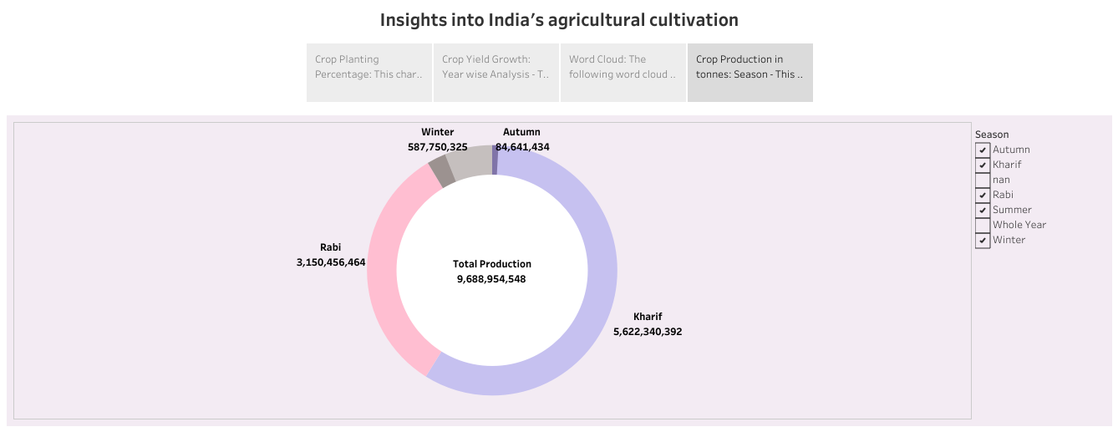

1. **ADVANTAGES & DISADVANTAGES:**
   1. **ADVANTAGES:**

* **Controlling diseases:** It helps in controlling insects, pests and soil borne diseases. It also controls weeds.
* **Irrigation:** Crops requiring high irrigation if followed by light irrigation, this will not affect or deteriorate the soil physical condition.
* **Employment:** Family and farm labour, power, equipment and machines are well employed throught the year.
* **Demand and price:** Farmers get a better price for his product due to higher demand in local market. So there is a regular flow of income over year.
* **Improvement of soil structure:** It improves soil structure, percolation and reduces changes of creation of hard-pan in sub soil and also reduces soil erosion.
* **Decision support:** By having access to data-driven recommendations and predictions, farmers can make more informed and optimized decisions.
* **Performance evaluation:** Farmers make informed decisions regarding adoption of new techniques or varieties, employing pest management techniques, or diversifying crop portfolios.
* **Cost savings:** Agriculture leads to cost savings in terms of fertilizers, pesticides, water and energy.
* **Diversification of crops:** It reduces risk of financial lloss due unfavourable conditions.

**4.2DISADVANTAGES:**

* **Environmental degradation:** Intensive agriculture can lead to soil erosion, deforestation, water pollution and loss of biodiversity.
* **Depletion of natural resources:** It can lead to depletion of natural resources such as water and soil, and can lead to land degradation and desertification.
* **Pesticide and fertilizer use:** The use of pesticides and fertilizers can harm human health and the environment, and can also lead to the development of pesticide-resistant pests.
* **Monoculture:** Large-scale monoscale farming can lead to loss of genetic diversity and can increase the risk of crop failures.
* **Climate change:** It is responsible for a significant portio of greenhouse gas emmitions and contributes to climate change.
* **Dependence of fossil fuels:** Modern agriculture id heavily dependent on fossil fuels for production, processing and transportation of crops.
* **Food safety and Quality:** The use of chemical fertilizers and pesticides can affect the quality and safety to food, and also can lead to health problems.
* **Labour exploitation:** The agriculture industry has been known for exploitaation of labour, particularly among mirant workers and children.
* **Price volatility:** The products are subject to perice volatility due to weather conditions, pest and disease and other factors.

**5.APPLICATIONS:**

* **Food production:** Crop production plays a crucial role in providing stable crops like grains, vegetables, fruits, and oil seeds that form the basics of human nutrition.
* **Livestock feed:** Crop production involves cultivating crops such as corn, soybeans, alfalfa, and fodder crops that are used as feed ingredients for livestock and poultry.
* **Fiber production:** Certain crops, such as cotton, jute, and flax, are used in the textile industry to produce fabrics, clothing, ropes and various other fiber-based products.
* **Bioenergy production:** Crops like sugarcane, corn, and switchgrasses are grown for biofuel production, such as ethanol and biodiesel, to reduce reliance on fossil fuels and promote renewable energy sources.
* **Medicinal and herbal crops:** These crops, such as aloe vera, lavendar, and medicinal herbs, are grown for their therapeutic properties and pharmaceutical applications.
* **Sustainable agriculture:** This involves employing environmentally friendly methods, such as organic farming, conservation agriculture, and precision farming, to reduce the environmental Impact of crop production and promote long term sustainability.
* **Research and innovation:** Researches work on developing new crop varieties, improving cultivation techniques, and finding solutions to crop pests, diseases, and environmental challenges.
* **Export and trade:** In terms of quality and quantity, influences international trade and contributes to the economy.
* **Industrial uses:** Hemp, for example, is used in the production of fibres, textiles, construction materials, bio plastics, and other industrial products.

**6.CONCLUSION:**

Agricultural crop production is a vital component of the agricultural sector, with a wide range of applications and significance. It plays a crucial role in feeding the growing global population, producing animal feed, and contributing to various industrial sectors such as textiles, bio-energy, and pharmaceuticals. Crop production enables the cultivation of diverse crops for food, fiber, medicinal purposes, and ornamental use. As the world faces various challenges, including population growth, climate change, and resource scarcity, the application of crop production becomes increasingly important in meeting these challenges and creating a resilient and productive agricultural sector.

**7. Future scopes:**

* **Adoption of precision agriculture:**

Precision agriculture involves the use of advanced technologies such as remote sensing, drones, and GPS-guided machinery.

These technologies allow for precise and targeted application of inputs, such as fertilizers and pesticides, based on real-time data.

Implementing precision agriculture techniques can increase efficiency, optimize resource utilization, minimize environmental impact, and improve crop yields.

* **Utilization of advanced analytics and AI:**

Incorporating advanced analytics and artificial intelligence (AI) can enhance decision-making in crop production.

AI algorithms can analyze large datasets and provide insights on crop performance, disease detection, pest management, and yield optimization.

This helps farmers make informed decisions and take proactive measures to improve crop health and productivity.

* **Development of climate-resilient crops**:

With climate change affecting agricultural systems, breeding and developing climate-resilient crop varieties is vital.

Scientists and researchers can focus on developing crops that are more tolerant to drought, heat, salinity, or pests and diseases.

This would help farmers adapt to changing environmental conditions and maintain productivity, even in challenging climates.

* **Vertical farming and controlled environments:**

Vertical farming, hydroponics, and controlled-environment agriculture offer opportunities for year-round crop production in urban areas and regions with limited arable land.

These methods involve growing crops in indoor environments, often using hydroponic systems and LED lighting.

Implementing such technologies can increase food production efficiency, reduce water usage, decrease transportation costs, and provide local access to fresh produce.